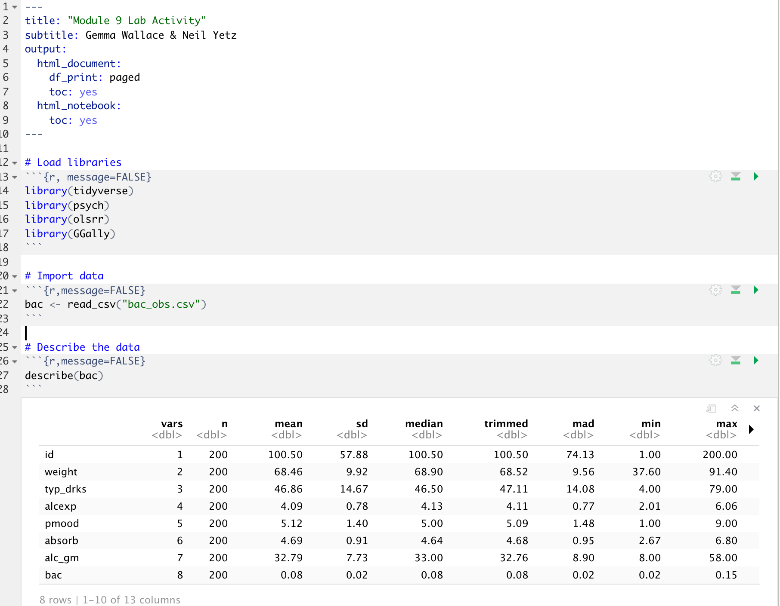

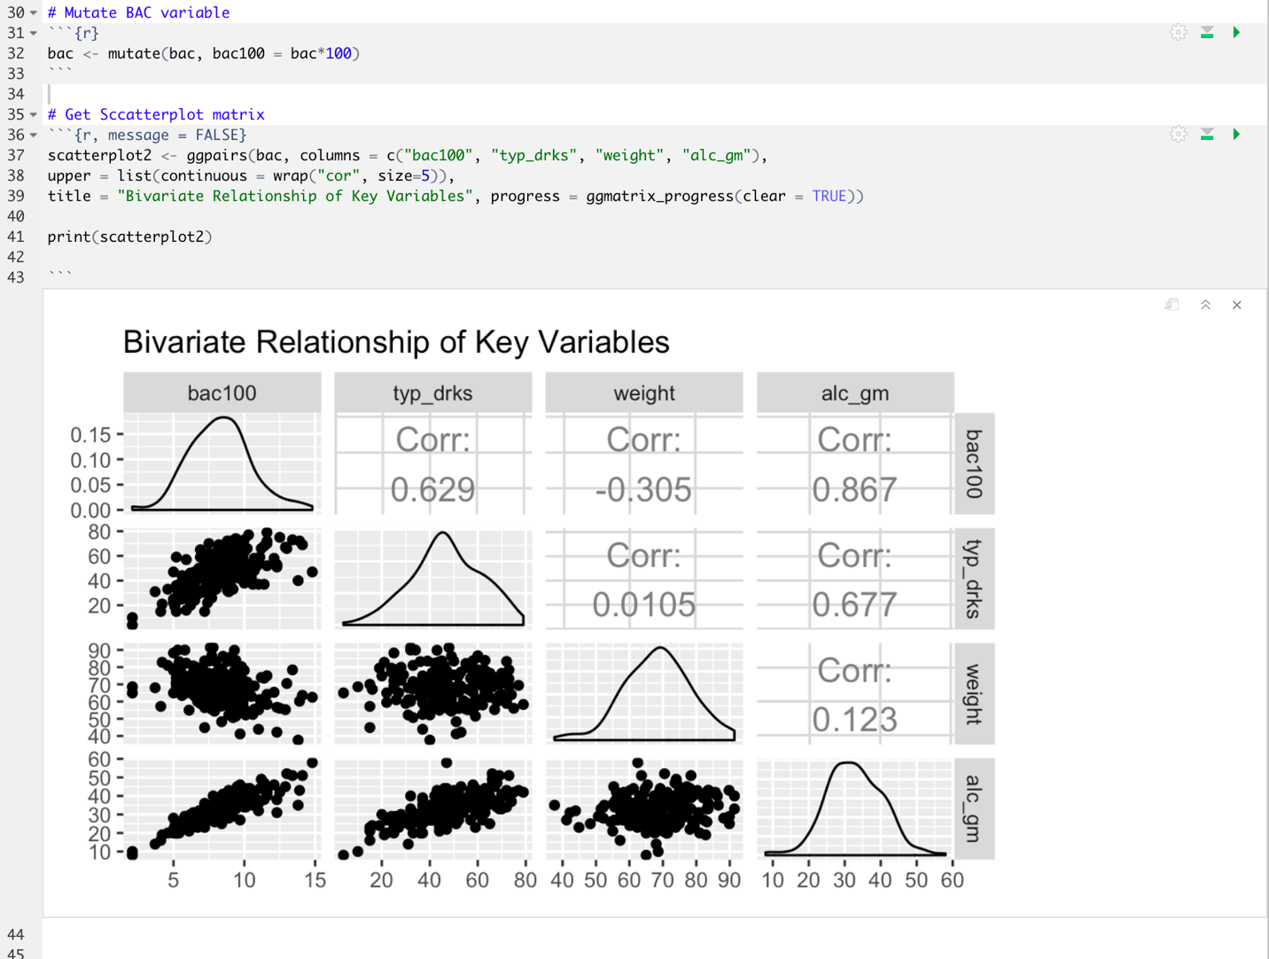

The plot above presents the distributions (via a density plot) for each individual variable, along with scatterplots and correlations for each pair of included variables. All four variables appear to have a roughly normal distribution. The plot indicates that there are large, positive correlations between alc_gm and bac100, between typ_drks and bac100, and between typ_drks and alg_gm.

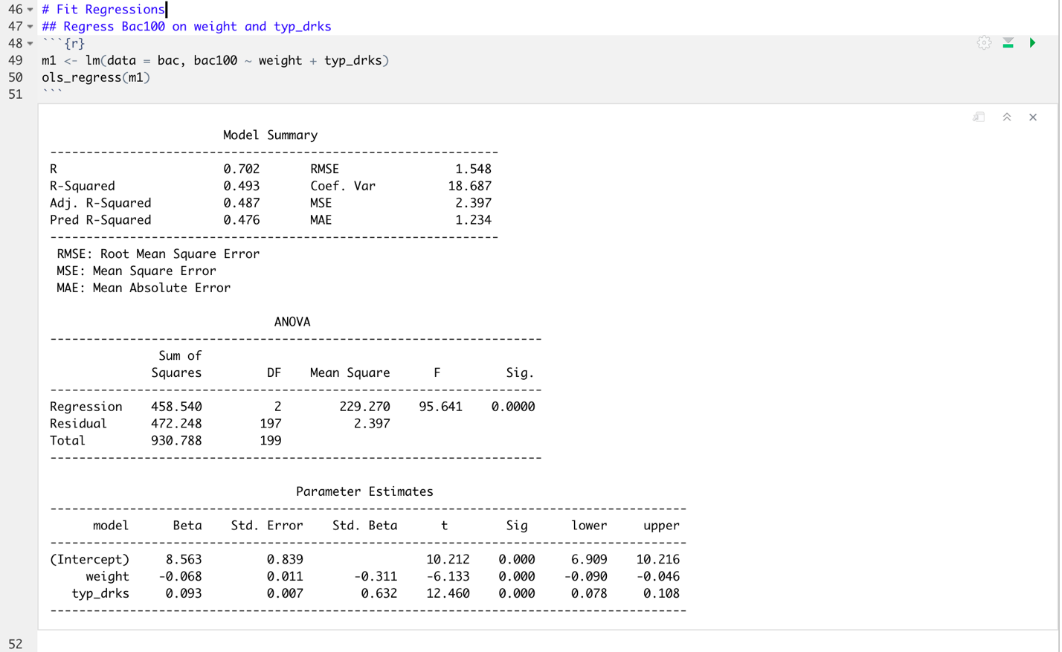

8d

The intercept, 8.563, represents the expected value in y (in this case bac100) when both predictors (weight and typ_drks) are equal to zero.

The beta estimate for weight, -0.068, is the expected change in bac100 for a one-unit increase in weight *while holding constant* (i.e., controlling for) typ_drks. In other words, when typ_drks is controlled for, a one-unit increase in weight is expected to result in a 0.068 unit decrease in bac100. The confidence interval for the weight beta does not include zero and *p*<0.001, indicating that this effect is statistically significant.

The beta estimate for typ­_drks, 0.093, is the expected change in bac100 for a one-unit increase in typ_drks *while holding constant* weight. In other words, when weight is controlled for, a one-unit increase in typ_drks is expected to result in a 0.093 increase in bac100. The confidence interval for the typ_drks beta does not include zero and *p*<0.001, indicating that this effect is statistically significant.

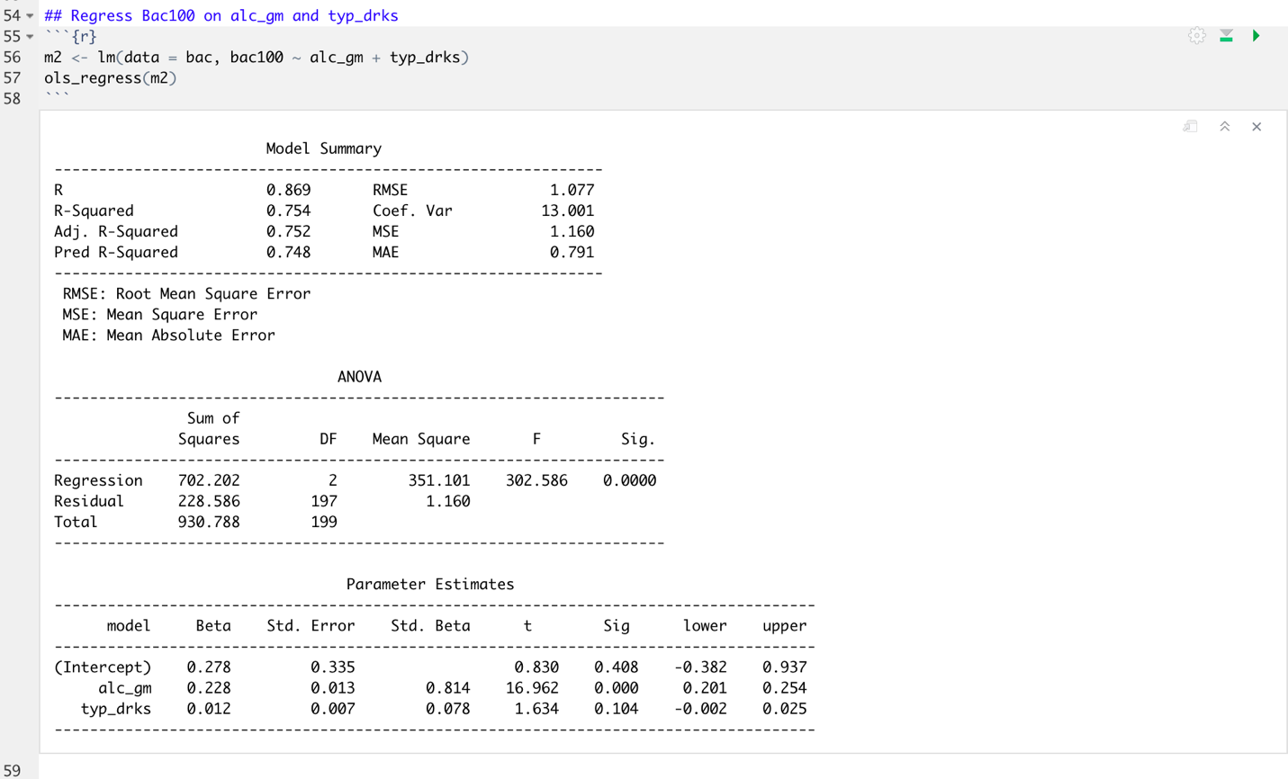

8d

The intercept, 0.278, represents the expected value in bac100 when both alc_gm and typ_drks equal zero.

The beta estimate for alc_gm indicates that, when controlling for typ_drks, a one-unit increase in alc_gm is expected to result in a 0.228 increase in bac100. The confidence interval for this estimate does not include zero and *p*<0.001, indicating that this effect is statistically significant.

The beta estimate for typ_drks indicates that, when controlling for alc_gm, a one-unit increase in typ_drks is expected to result in a 0.012 increase in bac100. The confidence interval for this estimate includes zero and *p>*0.100, indicating that this effect is not statistically significant.

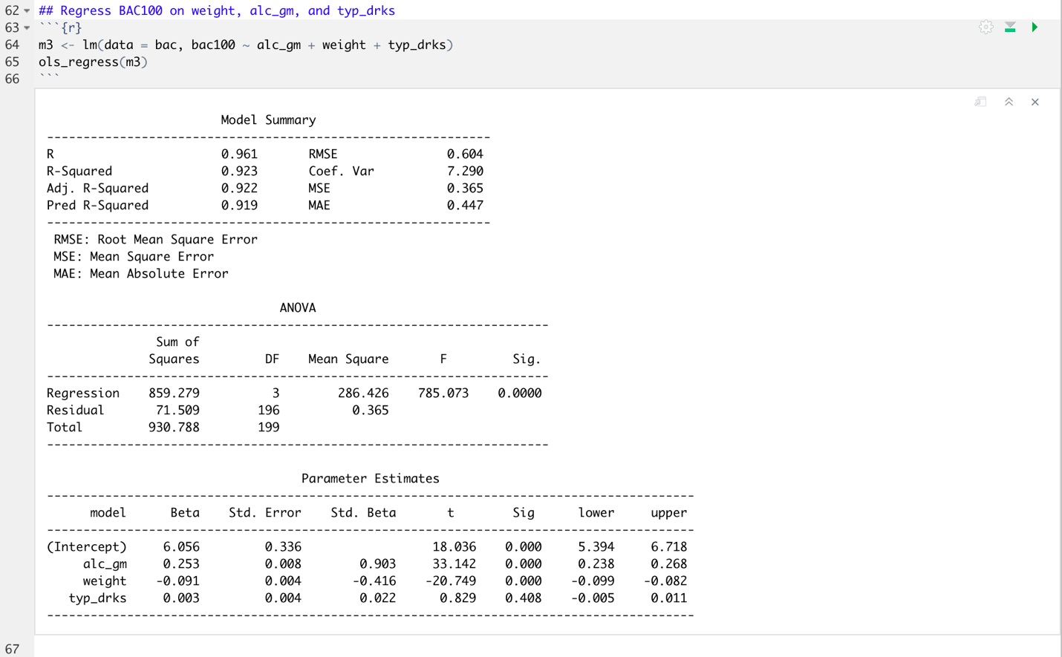

8d

The intercept, 6.056, represents the expected value of bac100 when all three model predictors (alc_gm, weight, and typ_drks) are equal to zero.

The beta estimate for alc_gm indicates that, while controlling for both weight and typ_drks, a one-unit increase in alc_gm is expected to result in a 0.253 increase in bac100. The confidence interval for this estimate does not include zero and *p*<0.001, indicating that this effect is statistically significant.

The beta estimate for weight indicates that, while controlling for both alc_gm and typ_drks, a one-unit increase in weight is expected to result in a 0.091 decrease in bac100. The confidence interval for this estimate does not include zero and *p*<0.001, indicating that this effect is statistically significant.

The beta estimate for typ_drks indicates that, while controlling for both alc_gm and weight, a one-unit increase in typ_drks is expected to result in a 0.003 unit increase in bac100. The confidence interval for this estimate includes zero and *p>*0.100, indicating that this effect is not statistically significant.

8e – part i

The model R2  value increased across the three models, indicating that each subsequent model explained more variance in bac100 than the previous model. In general, increasing the number of predictors in your model increases the model R2, since more predictors often means that a greater proportion of the unique variance in y is accounted for. In the next module, we’ll discuss how to balance maximizing model explanatory power without overfitting to your data via hierarchical regression.

8e – part ii

MLR is essentially a semi-partial correlation, in which the beta estimate for each predictor represents the expected relation between that variable and y when controlling for (or partialing out) the impacts of other predictors. In this example, the beta estimate for typ_drks is significant when only controlling for the effects of weight (model 1), but it is not significant when controlling for either alc_gm (model 2) or both weight and alc_gm (model 3). This indicates that typ_drks does not explain a significant amount of the unique variance in bac100 when the effects of alc_gm on typ_drks is removed.

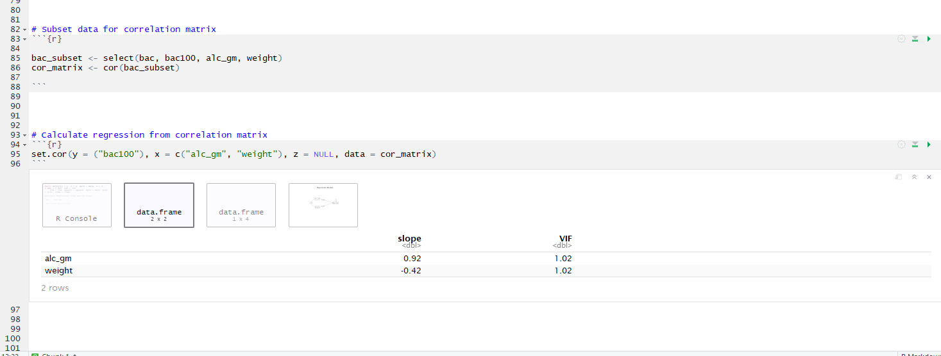

The slope values for alc_gm & weight are equivalent to the standardized slopes in our regression model above.

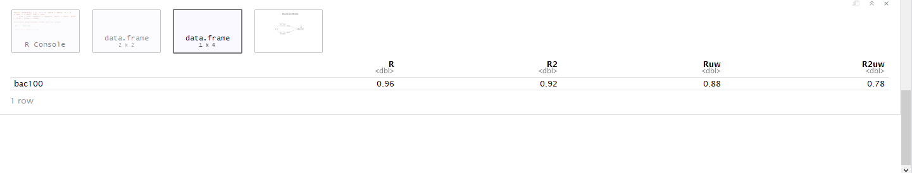

The R and R2 values are equivalent to the multiple regression model with the exact same parameters specified.

This method may be preferable if you need to weight one variable more than the other. MLR uses optimal weights to reduce the squared errors as much as possible. However, if you, as the researcher, know that alc_gm should be weighted differently, then you would need to use the correlation matrix and perform matrix algebra to weight them appropriately.